# Testing – Pre-Testing

|  |  |  |  |  |
| --- | --- | --- | --- | --- |
| Test No. | What is being tested? | Test Data | Testing Strategy (Good, Bad, Boundary) | Expected result |
| 1 | Shopping list, (add) | items: milk , eggs | good | Eggs and milk is added to the shopping list |
| 2 | Shopping list ,(remove) | All items | Good | All items are removed |
| 3 | Add ingredient to the fridge | Items:  Eggs = 8  Milk = 200ml | Good | Items are shown in the fridge list with amount |
| 4 | Remove items from the fridge | All items | good | All items are removed from the list |

# Test Results – Test Number 1

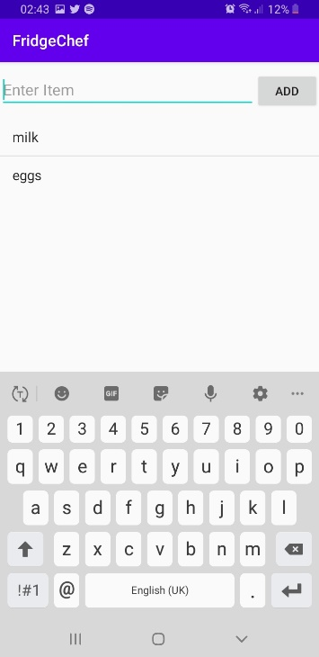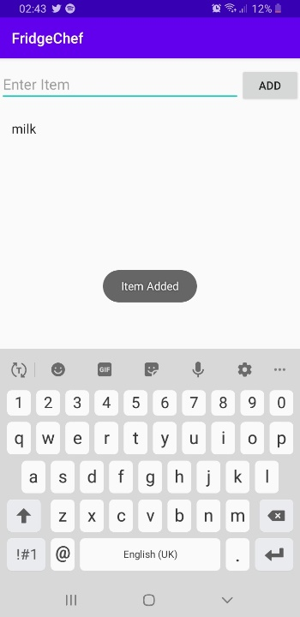

milk has been added to the shopping list,

and we get a confirmation message.

Milk and eggs have been added to the list

# Test Number 2

All items have been removed, and we get a message saying “Deleted”

# Test Number 3

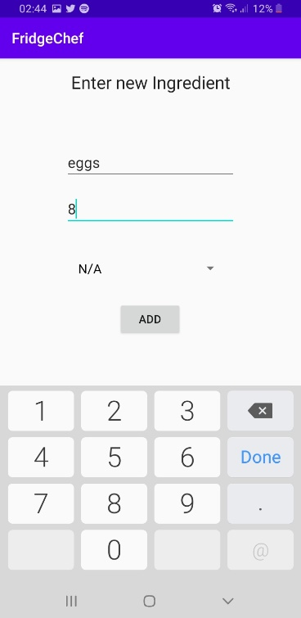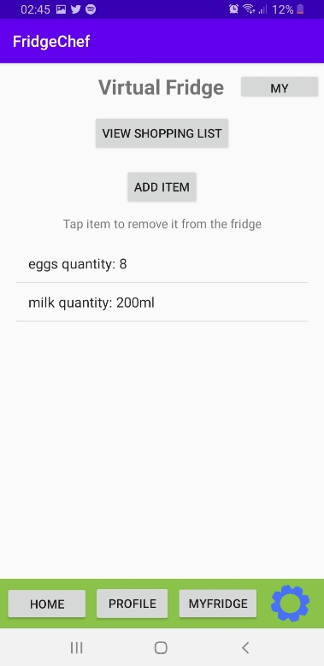

I added 2 items with different measurement units to the fridge.

We can see them in the second screen shot.

# Test Number 4

All items have been removed and the fringe is empty.

# Testing – Post-Testing

|  |  |  |  |  |  |  |
| --- | --- | --- | --- | --- | --- | --- |
| Test No. | What is being tested? | Test Data | Testing Strategy (Good, Bad, Boundary) | Expected result | Actual result | Actions needed |
| 1 | Shopping list, (add) | items: milk , eggs | Good | items are added to the list | Items are shows in the list | Hide keyboard when an item has been added |
| 2 | Shopping list ,(remove) | All items | Good | Items are removed from the list when double taped | All items are removed and shopping list is empty |  |
| 3 | Add ingredient to the fridge | Items:  Eggs = 8  Milk = 200ml | Good | Items are saved in the fridge with the correct measurement unit. | The result matches the input, | When an item is added the app navigates back to the home page when it should go to the fridge |
| 4 | Remove items from the fridge | All items | Good | Items are removed from the list when double taped | Items are removed and list is empty |  |

*further improvements:

When you double tap an item in the fridge to remove it you should get a window asking how many or all !!

(not sure if this should be in testing remove it if you want)